2018 Leaving Cert Physics Solution (Ordinary Level)

2018 no.1
- Draw a labelled diagram of the apparatus used in this experiment.
Labelled diagram to show:
Enclosed volume of gas / air
Method of measuring volume e.g. volume scale
Method of measuring pressure e.g. pressure gauge
Method of varying pressure / volume

- How were the pressure and volume measured?
Measure the pressure from the pressure gauge
Measure the volume of trapped air from the scale on the tube

- Copy and complete the table.

V (cm³) | 2 | 3 | 4 | 5 | 6 | 9
p (kPa) | 535 | 350 | 270 | 215 | 180 | 120
1/V (cm⁻³) | 0.5 | 0.33 | 0.25 | 0.2 | 0.17 | 0.11

- Explain how the data can be used to verify Boyle’s law.
Graph of p versus 1/V
Straight line through origin shows that pressure is proportional to 1/volume

- State two precautions which the student might have taken to improve the accuracy of this experiment.
After changing pressure wait a short time
Read the volume of the oil from the bottom of the meniscus
Read the volume scale at eye level/no parallax

2018 no.2
- Draw a labelled diagram of the apparatus used in this experiment.
labelled diagram to show:
Beaker of water
Standard thermometer
Uncalibrated thermometer
Heat source
Means of recording thermometric property
Detail to improve the accuracy e.g. stirrer
- What measurements were taken during this experiment?
Thermometric property
Temperature

- Use the data in the table to draw a graph, on graph paper, to establish the calibration curve.
Put temperature on the horizontal (X) axis.

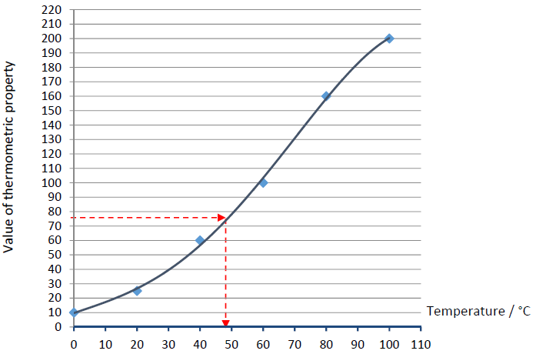
- Use your graph to determine the temperature when the value of the thermometric property is 75.
See graph.
48⁰ C

2018 no.3
- Draw a labelled diagram of the apparatus used in this experiment.
labelled diagram to show:
string
means of tightening
means of changing frequency e.g. tuning forks / frequency generator
means of varying length e.g. bridge
means of measuring length
means of detecting resonance /paper rider /magnet
detail e.g. sonometer
- Indicate on your diagram the length of the string that was measured.
distance between bridges
- Describe how the string was set vibrating.
placed a vibrating tuning fork on the bridge // turned on frequency generator
- How was the frequency of the string determined?
Read the value from the tuning fork/ frequency generator
- Sketch a graph to show the relationship between l and f that you would expect to obtain.
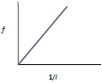

2018 no.4.
- Draw a labelled diagram of the apparatus used in this experiment.
labelled diagram to show:
length of wire
means of measuring resistance
means of measuring length/diameter/cross‐sectional area
- What measurements were taken during this experiment?
length
resistance
diameter
- How were these measurements used to calculate the resistivity?
Using the formula
- State two precautions which the student might have taken to improve the accuracy of this experiment.
Remove kinks from wire
Repeat the diameter measurement / take many readings (and get an average)
Use a long length
Ensure the resistance of the leads connecting to the ohmmeter is low
Check for zero error in micrometer, etc.
- no.5
- State Newton’s first law of motion.
A body will remain at rest or moving at a constant velocity unless an external force acts on it.

- Calculate the refractive index of the glass block shown in the diagram.
$ŋ=\frac{\sin{i}}{\sin{r}}= \frac{\sin{40}}{\sin{25}}$ = 1.52

- Choose from the list below the instrument used to measure (i) energy and (ii) resistance.
Energy: joulemeter
Resistance: ohmmeter

- State one use for a semiconductor diode.
rectifier, LED, switches, p.s.u.,
- State one use for the instrument shown.
measure angles/ measure wavelength of light /
demonstrate interference / demonstrate diffraction /
demonstrate spectra / demonstrate monochromatic light
- Define capacitance.
Capacitance is the ratio of charge to potential
- State two characteristics of a musical note.
loudness, amplitude, pitch, frequency, overtone, timbre/quality
- Sketch the magnetic field around a bar magnet.
See diagram
- Name two sources of ionising radiation.
sun, cosmic, named radioactive element, nuclear weapons,
nuclear power plants, etc.
- State one application of the photoelectric effect.
Solar panels, burglar alarms, automatic doors, control of burners in central heating, soundtrack in films, etc.

2018 no.6
- Define momentum.
Mass multiplied by velocity / p = mv
- Define kinetic energy.
Energy due to motion OR ½mv²
- Use the principle of conservation of momentum to explain why the cannon recoils.
Cannon recoils to ensure the momentum after is zero //to conserve momentum
/momentum before collision = momentum after collision

Bumper car A of mass 500 kg is moving with a speed of 6 m s⁻¹ when it collides with stationary bumper car B of mass 300 kg. After the collision the cars move together.

- Calculate the momentum of each car before the collision.
Momentum of A= m_{A}v_{A}= (500)(6) = 3000 kg m s^{‐1}
Momentum of B= m_{B}v_{B}= (300)(0) = 0 kg m s^{‐1}

- What is the momentum of the combined cars after the collision?
total momentum before = total momentum after
Total momentum before = 3000 kg m s^{‐1}
So total momentum after = 3000 kg m s^{‐1}

- Calculate the speed of the two cars after the collision.
3000 + 0 = (m_{A} + m_{B})V₃
= (500+300) V₃
V₃ = 3.75 m s^{‐1}

- Calculate the kinetic energy of each car before the collision.
½mv² = ½(500)(6)² = 9000 J
½mv² = ½(300)(0)² = 0 J

- Calculate the kinetic energy of the cars after the collision.
½mv² = ½(500+300)(3.75)² = 5625 J
- What conclusion can be drawn from the change in kinetic energy that happens during the collision?
kinetic energy is not conserved / is lost

2018 no.7
- What is heat?
Heat is a form of energy

- What is meant by the temperature of an object?
Temperature is a measurement of hotness
- What is the unit of temperature on the SI scale?
The kelvin
- Express 20 °C in the units you have named in part (iii).
273+20 = 293 K

- Name the method by which heat is transferred in metals.
conduction // vibrating atoms (transfer energy)
- Name the two other methods of heat transfer.
convection, radiation
- How can this experiment be used to find out which metal is the best at allowing heat transfer?
the pin which falls first indicates the best conductor
- State two ways of making sure that this investigation is fair.
Ensure there is an equal amount of heat for each metal
Ensure that the metal strips are the same length / diameter
Ensure to have the same amount of wax, etc.
- Metals are good conductors. Name a good insulator.
Paper, plastic, wood, etc.

2018 no.8
  - Explain the terms diffraction
Diffraction is the bending/spreading out of waves around a barrier / the edges of an opening

  - Explain the term interference
Interference occurs when two waves meet and add
  - Describe an experiment to demonstrate the wave nature of light.
apparatus: (diffraction) grating / Young’s slits
procedure: shine the light through the grating /Young’s slits
observation/conclusion; pattern on screen

  - What is meant by polarisation?
polarisation is the restriction of (vibrating electromagnetic) waves to a single plane
  - Describe an experiment to demonstrate the polarisation of light.
Apparatus: (two pieces of a) polaroid sheet
Procedure: look at the light through the two pieces of polaroid
Rotate one of the polaroid pieces
Observation/conclusion; the crossed pieces stop the light
  - What three colours are used?
red, green, blue
  - Describe how these colours can be used to create any image.
these colours may be mixed (to give white light/ other colours)

2018 no.9
(a)
  - State Coulomb’s law of force between charges.
Force proportional to the product of charges and inversely proportional to the distance between the charges squared
  - State one use of an electroscope.
test for charge, identify charge, measure potential
  - How can an electroscope be given a positive charge?
Touch the cap with a positively charged conductor
OR
Bring a negatively charged rod close to the cap and earth the electroscope.
Remove the earth before removing the rod

  - What is observed when the cap of a charged electroscope is earthed?
The leaves collapse/converge / fall
  - Explain this observation.
Charges move (between the cap and the earth)
  - How could the cap of the electroscope be earthed?
by touching with a finger OR a conductor connected to earth

(b)
- State Ohm’s law.
The current through a conductor is directly proportional to the voltage
- Calculate the total resistance of the circuit.
6 + 12 = 18 Ω

- Calculate the current in the circuit.
I = $\frac{V}{R}= \frac{3}{18}$ = 0.166 A
- Calculate the potential difference across the 6 Ω resistor.
V = IR = (0.166)(6) = 1 V
- Name an instrument used to measure potential difference.
voltmeter

2018 no.10
  - What are X‐rays?
High energy (high frequency) electromagnetic waves

  - State two properties of X‐rays.
Short wavelength, cause ionisation, affect photographic plates, absorbed by bone/metal, no charge, etc.

  - What process occurs at part A?
Thermionic emission
  - Name a substance used in part B.
Tungsten
  - State the function of part C.
Prevent escape of X‐rays, shielding, protect (from X‐rays), etc.
  - State one use of X‐rays.
to photograph bones/ internal organs, to treat cancer, to detect flaws in materials, to determine the thickness of materials, etc.
  - Why is a vacuum needed inside an X‐ray tube?
So the electrons won’t collide and lose energy
  - Name another device that uses a beam of high speed electrons.
cathode ray tube, fluorescent light
  - State one use for the device you have named in part (vii).
CRO, medical devices, (old) TVs/screens
  - State one difference between X‐rays and gamma‐rays.
Different ways of production, different energy / wavelength /frequency/ penetration / ionising

2018 no.11

- What physical quantity is transmitted in a wave?
Energy
- Why do waves break close to the shore?
The wavelength decreases and the wave height (amplitude) increases
OR
Waves move into shallow water until the wave becomes unstable and breaks
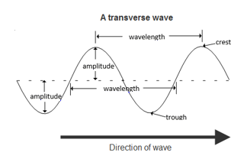
- Draw a diagram to show the main features of a wave.
See diagram

- State Archimedes' principle.
When a body is immersed in a fluid, the upthrust it experiences is equal to the weight of the fluid displaced
- What is meant by the term buoyancy (upthrust)?
An upward force exerted by a fluid
- How does buoyancy help the surfer to stay afloat?
counterbalances the weight
- Draw a labelled diagram to show the forces acting on a floating object.
Diagram to show: weight down, upthrust up
- Explain how the stance of the surfer shown helps her to balance.
Low centre of gravity OR wide stance

2018 no.12

12 (a)
- Define velocity.
velocity is the rate of change of displacement OR velocity = displacement divided by time

- Define acceleration.
Acceleration is the rate change in velocity OR acceleration = change in velocity divided by time taken.
- Calculate how long it took the train to reach its top speed.
$$t=\frac{v-u}{a}= \frac{55-0}{0.4}$$

= 137.5 seconds
- How far did the train travel while at its top speed?
s = (speed)(time) = (300)(55) = 16500 m
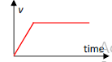
- Draw a velocity‐time graph of the train’s journey.
See diagram

12 (b)

  - How could you show the different colours present in visible light?
Apparatus: white light source, screen, prism/CD/grating
Shine the light through the prism/CD/grating

  - What do the letters U and V stand for?
Ultraviolet

  - Compare the wavelength of UV radiation to the wavelength of infra‐red (IR) radiation.
ultraviolet has a shorter wavelength
  - Describe how to detect UV radiation.
Florescent material will fluoresce/glow

  - State one use of UV radiation.
Detect forged currency, disco lights, used in insect removal device, sterilisation, suntan, forensics, etc.

12 (c)

- Calculate the energy needed to raise the temperature of the water from 20 ⁰C to 90 ⁰C.
Q = mcΔθ = (0.7)(4200) (90-20) = 205800 J

- How many joules of energy are supplied per second by the boiler?
3000
- Calculate how long it will take the boiler to heat the water to 90 ⁰C.
Pork = Work/time so t = Work/Power t = 205800/3000 = 68.6 secs.

- Where should the manufacturer place the heating element of the boiler? Explain your answer.
At the bottom, because cold water is more dense and will sink down

12 (d)

- What is electromagnetic induction?
Electromagnetic Induction occurs when an emf is induced in a coil due to a changing magnetic flux.
- Explain how you would use a magnet and a coil, as shown above, to produce electricity.
Move the magnet into/out of the coil
- How would you know that electricity is being produced?
deflection /pointer moves / from the meter
- How could you increase the magnitude of the electricity produced?
move faster / use a stronger magnet / use more coils
- What is meant by a.c.?
Alternating current

